A Surgeon’s Little-Known Secret to Biohacking Your Body With Oxygen Therapy
You may remember Dr. Johnathan Edwards, MD: an endurance athlete, private practice anesthesiologist, physiologist and sports medicine physician based in Las Vegas, and a guy who consults with a huge number of professional athletes in many different disciplines in North America and Europe, including cyclists in the Tour de France, AMA motocross athletes and UFC fighters.
A few weeks ago, here at BenGreenfieldFitness.com, Dr. Edwards wrote The Ultimate Guide To Biohacking Exercise With Oxygen Therapy, Hypoxia, Elevation & Altitude Training, and in that article, Dr. Edwards touched on the surprising things you can do to enhance physical and mental performance if you know how to use oxygen the right way. In that article, you learned that if you want a shortcut to maximizing lung capacity and recovery you can (and should) increase the amount of oxygen available to your body via a protocol called “Exercise With Oxygen Therapy”, or “EWOT”.
Problem is, it can be incredibly difficult to figure out how to get an oxygen concentrator, how to “hack” it to be efficient enough for EWOT, and then what to do with it once you have your oxygen concentrator all setup. Sure you could buy an oxygen concentrator just like the one you’re about to learn to make, but it’s going to set you back $5000 or more. In other words, this stuff can be confusing and can be expensive. That’s probably why Dr. Edward’s original article received plenty of comments and questions about EWOT.
But it’s actually not that difficult and quite inexpensive to make yourself an oxygen concentrator that rivals what is used in fancy sports science and exercise physiology labs.
So now, without further ado, I present to you…
…a new article from Dr. Edwards that shows you exactly how to get, how to biohack, and how to use an oxygen concentrator.
If you’re one of the guys or girls who simply isn’t technically or engineer minded, but who wants all the biohacking benefits of exercise with oxygen therapy, I’d recommend you post this article to Craiglist to find someone to make it for you, or give this article to your closest friend who you know loves to do projects like this, and have them make it for you. You’re still going to literally save thousands and thousands of dollars.
Finally, please note that this is not medical advice or medical device, and the information you’re about to read is meant for educational purposes only.
-----------------
The popularity of oxygen therapy has skyrocketed in recent years.
Athletes are now using concentrated oxygen for recovery and to gain an athletic advantage. Tiger Woods, Michael Phelps, Mario Lemieux, Olympic athletes, multiple players in the NBA, NFL and professional baseball all use some type of oxygen therapy.
As an anesthesiologist, I have a unique perspective on oxygen, having spent much of my career providing oxygen to patients during surgery. I also use oxygen therapy outside the operating room for sports and medical applications such as healing diabetic wounds, treating firefighters with carbon monoxide poisoning and other ailments. And I have other patients who use it simply because they believe it will enhance their physical or mental performance. Supplemental oxygen has even been touted to improve sex!
But getting access to oxygen therapy can be an expensive and difficult endeavor. Your two main options are hyperbaric oxygen (HBO) therapy or mask oxygen. These both produce an increase in tissue oxygen concentrations in your body. Hyperbaric therapy increases the oxygen via increases in atmospheric pressure in a sealed space. A mask system increases oxygen via a sealed mask that delivers oxygen with a tank or oxygen concentrator machine. The first option, hyperbaric oxygen therapy units, is a very expensive option. But the second options, an oxygen concentrator, is much less expensive and quite easy to use in your own home.
I am not going to delve into the micro details about the amazing things that happen to your body and tissues when you use supplemental oxygen. For that, please go back and read the The Ultimate Guide To Biohacking Exercise With Oxygen Therapy, Hypoxia, Elevation & Altitude Training.
Instead, I want to dive into the nitty-gritty of how to hack your oxygen levels using an oxygen concentrator.
----------------------
So how can you optimize the amount of oxygen delivered to your body?
As stated above, you could use a hyperbaric setup or you could use an oxygen concentrator. An oxygen concentrator is a machine that basically pressurizes room air, separates the oxygen from the nitrogen, and delivers a high concentration of oxygen through one port and a hypoxic mixture of air through another port. You may recall that in the article I wrote for BenGreenfieldFitness a couple weeks ago, I mentioned:
“You can buy an oxygen concentrator new online for as little as 300 dollars, but I suggest looking up an oxygen concentrator repair shop in your area and inquire about buying a new or refurbished oxygen concentrator. Get one that puts out at least 5 liters per minute. My friend Andy Champagne from O2CRS, a local shop in Las Vegas, is very knowledgeable and has reasonably priced units.”
So, let’s say you’ve got your oxygen concentrator. Often the oxygen port will be on the top of the machine. A hypoxic port is inside in the machine. Here’s what the average oxygen concentrator looks like:
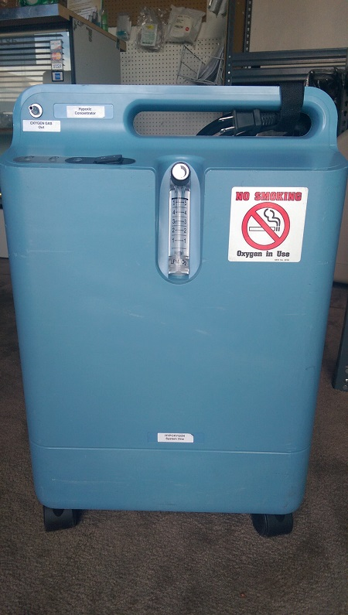
A typical oxygen concentrator. There is a dial for adjusting the flow of oxygen and the port is located on the upper right of the machine.

Most oxygen concentrators deliver about 5 liters per minute, and some as high as 10 liters per minute. To obtain high oxygen levels, a sealed mask system connected to a reservoir is essential. Regular mask systems allow too much of something called “air entrainment”. The volume of the reservoir is important and needs to be at least 100 liters.
Simple math tells you that you will run out of oxygen pretty quickly without a large reservoir. Breathing normally, you inspire about a half a liter per breath, and this increases significantly during exercise. This is the reason for those super big bags from companies like the LiveO2 system. I have found that at least 100 to 200-liter reservoir is needed for most 30-60 minute exercise with oxygen therapy (EWOT) sessions.
----------------------
OK, now, here are the instructions for biohacking your oxygen concentrator:
Step 1: Obtain an oxygen concentrator. Scroll up and read again, search the internet, or contact Andy at O2CRS. If possible, consider buying a 10-liter machine, but a 5-liter machine does the job just fine.
Step 2: Make the reservoir.
Materials required to make the reservoir bag:
-a roll of thick 4 mm (or more) plastic
- a ¾ inch PVC reducer bushing
-½ inch PVC coupler
-½ inch PVC cap
- a CPAP adapter
You can purchase the CPAP adaptor at O2CRS or from Alibaba.com, and the rest you can buy from your local home improvement store. Below are photos of the PVC coupler, the bushing and the CPAP adapter. Just comment below this article if you’re confused about any of the materials you’ll need, and I’d be happy to reply.
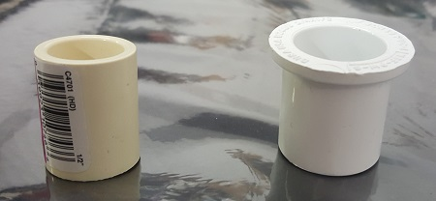
On the left, the ½ inch PVC coupler, on the right, a ¾ inch PVC reducer bushing.

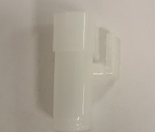
CPAP adaptor. This piece attaches to the ½ inch coupler on one side and CPAP tubing on the other. It also has a port to attach the oxygen tubing.
The plastic required for the reservoir bag needs to be at least 4 millimeters thick or more. Most fabric stores sell a thick plastic that come in a roll.
Lay the plastic on a flat surface, and then, using a heat gun or iron, heat the ends of the plastic together on each side, leaving the bottom unsealed. An iron is recommended, set on a low heat setting. Heat around the edges, sealing three sides of the bag only.

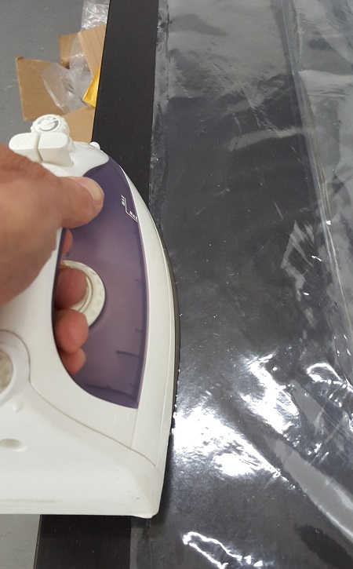
Use an iron on low heat to melt the two edges of the thick plastic together. This step may need to be repeated several times.

At the bottom of the bag near the unsealed opening, cut an "X" about ½ inch in diameter. Place the ¾ inch reducer bushing inside the bag just under the opening that was cut into the plastic. Then place the ½ inch coupler on top of the “X” on the outside of the bag. Now push the two pieces together, forcing the plastic into larger ¾ inch coupler. This is what creates the seal. It should look like this:

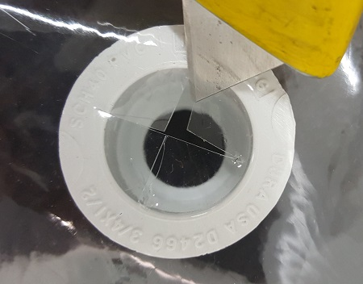

After placing the ¾ inch reducer bushing under the plastic, cut an “X” in order to insert the ½ inch coupler into the reducer bushing.
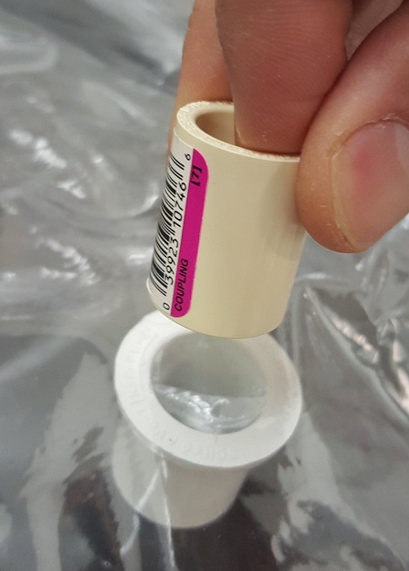

Firmly insert the ½ inch coupler into the reducer bushing. This seals the fitting into the plastic.
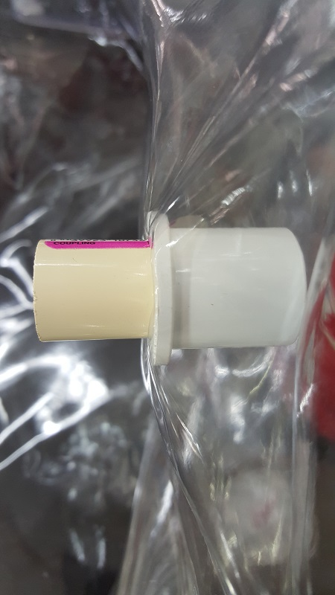
The coupler and reducer bushing successfully inserted into the plastic.

Now attach the CPAP adapter to the ½ inch PVC reducer bushing and put the ½ inch PVC cap onto the end of the CPAP adapter port. Now the bottom of the reservoir bag can be finished by sealing the open end with the heat gun or iron.
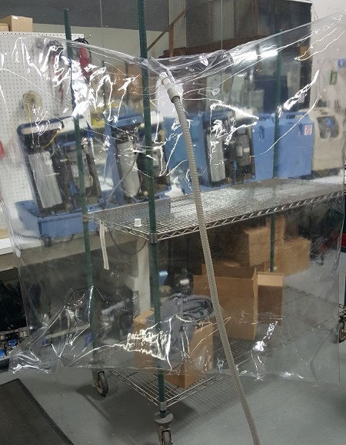
Inflating the reservoir with oxygen. Notice the oxygen tubing at the top. The CPAP tubing is attached to the ½ inch coupler.
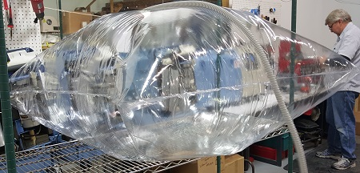
The reservoir fully inflated and holding about 200 liters of oxygen. Be careful to not overfill as the bag will come apart with too much pressure.

Step 3: Attach the tubing. Obtain an oxygen line that will connect to the machine to the oxygen outlet on the CPAP adaptor. This is usually a thin, plastic tubing that should come with the oxygen concentrator. Attach the tubing to the machine and to the oxygen outlet on the CPAP adaptor.
Step 4: Connect the CPAP tubing to the CPAP adapter. You can obtain CPAP and oxygen tubing from most medical stores. Again, depending on your situation and how far your treadmill, exercise bike, etc. is from the actual oxygen concentrator, you will need at least 10 feet or more of CPAP tubing.
Step 5: Connect the CPAP tube to the mask. The mask is a dual one-way valve that is quite easy to get from a medical store. Be sure to connect the CPAP tubing to the intake port of the mask, you will exhale out of the out-take port.
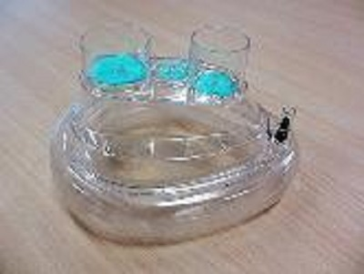
Dual valve oxygen mask.
Once everything is connected, simply turn the machine on and let it run. Be sure the reservoir is capped off. The oxygen concentrator has to fill the reservoir bag, so if you are filling at, say five liters per minute, this will take about sixty minutes for a 200-liter bag.
--------------------------
OK, so now you’re probably wondering how to use this contraption. Here goes…
The mask should fit comfortably on your face. Adjust the straps until you have a good fit. If there is any pain or there are any leaks, then the mask is not fitted correctly. A good seal is very important and you should be able to breath comfortably. If you have a 200-liter reservoir, breathing normally at sixteen times a minute will give you about thirty minutes of oxygen.
Using the mask oxygen system during exercise will deplete the reservoir much sooner, but it is still enough to do a good session.
One interval session that I use often on my bicycle trainer goes as follows:
-Be sure to fill the oxygen reservoir adequately before you start
-Warm up without oxygen until you reach your target pulse rate (usually 10-15 minutes)
-Put on the oxygen mask
-Sprint at 90 to 100% of your maximum power or heart rate for 30 seconds
-Rest about 1 to 1.5 minutes
-Repeat at least 8 to 10 times
-During the session, use a fingertip pulse oximeter to monitor your pulse rate and O2 saturation. You should see consistently high levels of oxygen saturation.
I also like to use an oxygen concentrator for enhancing recovery by literally just sitting on the couch and wearing the mask after a really hard workout or a race. In fact, a recent article published in the Journal of Strength and Conditioning Research showed that supplemental oxygen quickened recovery and improved muscle contractility after exercise. It also appears to speed up muscle tissue metabolism and increases tissue blood circulation.
For more ideas on hyperoxia and exercise with oxygen therapy protocols, you can check out plenty of tips on the internet. One site I particularly like for this is LiveO2.com and Ewot.com.
--------------------------------
Summary
So that’s it! Voila, you now have a system that will deliver oxygen at a high rate to your body during exercise, and in doing so, you’ll get all the performance-enhancing benefits I outline here.
Do you plan on using any of these oxygen biohacks? Was any of this confusing for you or do you need clarification on the design of the oxygen concentrator or the exercise protocol? Leave your comments, thoughts and feedback below, and I promise to reply.

